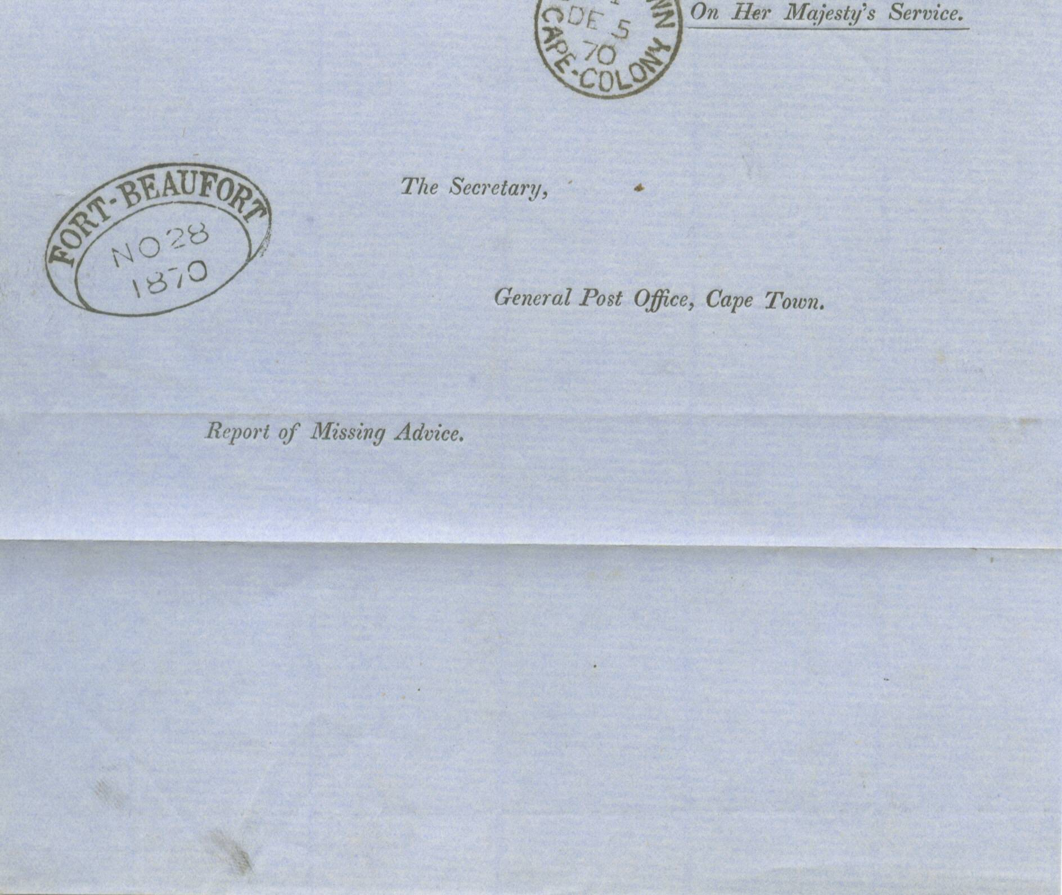
+

FORT-BEAUFORT TOWN OVAL HANDSTAMP

REPORT OF MISSING ADVICE

1870 Pre-printed “Report of Missing Advice” pale blue outer letter sheet, addressing “The Secretary, General Post Office, Cape Town ex Fort-Beaufort “NO 28 1870”, plus Cape Town arrival cds on front.

CAPE OF GOOD HOPE

DEVELOPENT OF POSTAL SERVICES

The Dated Town Oval

Handstamps of 1853

